**Assignment 19.1 Spark**

2. Problem Statement

Using spark-sql, Find:

<https://drive.google.com/drive/folders/0B_P3pWagdIrrTEVTVE1VWXI0YVk>

case class SPORTS (firstname: String , lastname: String, sports: String, medal: String , age: String, year: String, country: String)

val spt = sc.textFile("sport_data.txt").map(_.split(",")).map(p => SPORTS (p(0), p(1), p(2), p(3), p(4),p(5),p(6))).toDF()

spt.registerTempTable("sports");

val sport = sqlContext.sql("SELECT * FROM sports")

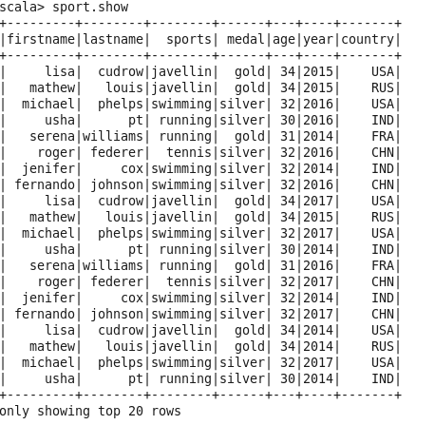

**1. What are the total number of gold medal winners every year**

val grp = sqlContext.sql("SELECT count(medal) as Gold_Medal, year,country from sports where medal == 'gold' group by year,country order by year ")

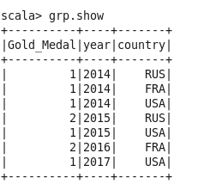

**2. How many silver medals have been won by USA in each sport**

val grp = sqlContext.sql("SELECT count(medal) as Medal, sports from sports where medal == 'silver' and country == 'USA' group by sports ")

